**POWER INVERTERS : SIMULATION**

*Submitted towards the fulfillment of the requirement for the*

*mid-term evaluation component of*

**ANALOG ELECTRONICS I**

*Submitted by*

**Aditya Raj**

**2K20/EC/014**

**Amrinder Singh Saini**

**2K20/EC/027**

Under the supervision

*of*

**Asst.Prof. Varun Sangwan**



**Department of Electronics & Communication Engineering**

Delhi Technological University

Bawana Road, Delhi - 110042

**DECLARATION**

We hereby certify that the work, which is presented in this project entitled **“POWER INVERTERS : SIMULATION”** in fulfillment of the requirement for the Mid-Term evaluation component in **Analog Electronics I** and Submitted to the Department of Electronics & Communication Engineering, Delhi Technological University, Delhi is an authentic record of our own, carried out under the supervision of Asst.Prof. Varun Sangwan.

The work presented in this report has not been submitted and not under consideration for the award of any other course of this or any other Institute/University.

**Aditya Raj Amrinder Singh Saini**

2K20/EC/014 2K20/EC/027

B.Tech, ECE B.Tech, ECE

**SUPERVISOR CERTIFICATE**

To the best of my knowledge, the report comprises original work and has not been submitted in part or full for any Course/Degree to this university or elsewhere as per the candidate’s declaration.

Place : Delhi **Supervisor Name and signature**

Date : 17/11/2021 Asst.Prof. Varun Sangwan

**DEPARTMENT OF ELECTRONICS & COMMUNICATION ENGINEERING**

DELHI TECHNOLOGICAL UNIVERSITY

(Formerly Delhi College of Engineering)

Bawana Road, Delhi - 110042

**CERTIFICATE**

We hereby certify that the project dissertation titled **“POWER INVERTERS : SIMULATION”** which is submitted by Aditya Raj [2K20/EC/014] and Amrinder Singh Saini [2K20/EC/027], [Electronics and Communication Engineering], Delhi Technological University, Delhi in fulfillment of the requirement for the mid-term evaluation component of Analog Electronics I, is a record of the project work carried out by the students under my supervision. To the best of my knowledge this work has not been submitted in part or full for any degree or diploma to this university or elsewhere.

Place : Delhi **SUPERVISOR**

Date : 17/11/2021 Asst.Prof. Varun Sangwan

**DEPARTMENT OF ELECTRONICS & COMMUNICATION ENGINEERING**

DELHI TECHNOLOGICAL UNIVERSITY

(Formerly Delhi College of Engineering)

Bawana Road, Delhi - 110042

**ABSTRACT**

The objective of this project report is to study Power Inverters that are used to efficiently convert a DC power source to a high voltage AC source.

Inverters are primarily used in situations which require a low voltage DC source like batteries to be converted to AC. Most of the electronic appliances run on AC, and in conditions when AC supply is not available, inverters can be used to convert DC from sources like batteries to power appliances. The most common use of inverters is domestically in homes where they come handy in situations of power cuts.

There exist basically two types of methods to convert DC to AC. In one of them, low voltage DC is first converted to AC and then a transformer is used to step up the voltage such that it is suitable for use. The other method is to convert a low voltage DC power to high voltage DC source source and then convert it to AC.

One of the most important aspects of this project is the highlighting of the components as to which components fit best for use and the reason for saying so. Implementation is important for any idea to progress and circuits have been implemented by design and simulation.

SIMULINK is used for the simulation of half bridge and full bridge inverter circuits.

**DEPARTMENT OF ELECTRONICS & COMMUNICATION ENGINEERING**

DELHI TECHNOLOGICAL UNIVERSITY

(Formerly Delhi College of Engineering)

Bawana Road, Delhi - 110042

**ACKNOWLEDGEMENT**

In performing our major project, we had to take help and guideline from some respected persons, who deserve our greatest gratitude. The completion of this assignment gives us much pleasure. We would like to show our gratitude to **Asst.Prof. Varun Sangwan ,** mentor for our major project. Giving us a good guideline for report throughout numerous consultations. We would like to extend our deepest gratitude to all those who have directly and indirectly guided us in writing this assignment.

Many people, including our classmates, have made valuable comment suggestions on this proposal which gave us inspiration to improve our assignment. We thank all the people for their help directly and indirectly to complete our assignment.

In addition, we would like to thank the Department of Electronics and Communication Engineering, Delhi Technological University for giving us the opportunity to work on this topic.

**CONTENTS**

1. TitlePage
2. Candidate’s Declaration
3. Certificate
4. Abstract
5. Acknowledgement
6. Contents
7. List of Figures
8. Chapter 1 - Introduction

8.1. Introduction to Inverters

8.2. Inverter Applications

8.3. Classification of Inverters

8.3.1. On the basis of output

8.3.2. On the basis of source of the Inverter

8.3.3. On the basis of the type of the Load

8.4. Scope of the Project

1. Chapter 2 - Inverter Design

9.1. Ideal Half Bridge Inverter

9.1.1. Operating conditions

9.1.2. Working

9.2. Choice of Components

9.2.1. MOSFET as Switch

9.2.2. PMOS or NMOS

9.2.3. Pulse Generator

9.2.4. Load

9.3. Practical Half Bridge Inverter using MOSFETs

9.3.1. Simulink Model

9.3.2. Working

9.3.3. Simulation Results

9.4. Ideal Full Bridge Inverter

9.3.1. Operating Conditions

9.5. Practical Full Bridge Inverter using MOSFETs

9.5.1. Simulink Model

9.5.2. Working

9.5.3. Simulation Results

9.6. Conclusion

1. Conclusion
2. Bibliography

**LIST OF FIGURES**

| Fig No. | Figure description |
| --- | --- |
| Fig. 1 | An inverter used for domestic applications |
| Fig. 2 | Different Output Waveforms |
| Fig. 3 | Schematic diagram of the Half Bridge Configuration |
| Fig. 4 | Simulink Model for Half Bridge Inverter |
| Fig. 5 | Current waveform for Resistive Load (HB) | HB = Half Bridge |
| Fig. 6 | Voltage waveform for Resistive Load (HB) |
| Fig. 7 | Current Waveform for RL Load (HB) |
| Fig. 8 | Voltage waveform for RL Load (HB) |
| Fig 9 | Schematic diagram for full bridge inverter |
| Fig 10 | Simulink Model for Full Bridge Inverter |
| Fig 11 | Current waveform for Resistive Load (FB) | FB = Full Bridge |
| Fig 12 | Voltage waveform for Resistive Load (FB) |
| Fig 13 | Current waveform for RL Load (FB) |
| Fig 14 | Voltage waveform for RL Load (FB) |

**CHAPTER 1**

**INTRODUCTION**

1. Introduction to Inverters

Power inverters, more commonly known as inverters, are electronic devices that consist of an inversion circuit which efficiently transforms a DC power source such as a battery to an AC power source. Inverters come handy in many applications owing to the fact that DC power can charge devices and AC power cannot. In situations where AC power is not available, inverters are used to convert stored DC power to AC power which can be used for all required purposes. As the majority of electronic devices run on AC power, therefore it is essential to convert DC power to AC power.

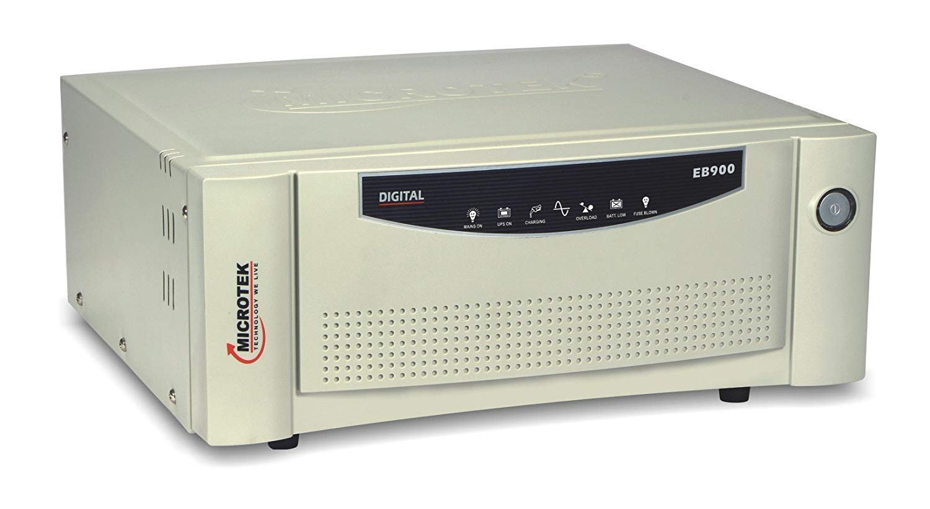

Fig 1 : An inverter used for domestic applications

There exist primarily two methods by which this inversion can take place. One of these methods involves converting the low voltage DC power source to a high voltage DC power source and then converting it to an AC power source by using Pulse width modulation. The other method involves converting the low voltage to DC power to a low voltage AC power and then stepping up this obtained AC power to a high voltage by the use of a transformer.

The first inverters that were constructed, used motor-generated sets and mechanical switches which ultimately made them costly, heavy and inefficient. However, advancements in the field of inverters have been rapid with their applications coming in for both domestic and commercial uses. Modern Inverters use solid-state designs and microprocessor controls which result in efficient conversion, thus delivering high quality AC power. This project report also focuses on the modern day inverters based on solid-state designs.

1. Inverter Applications

Ever since the development of inverters, they have found profound applications in both domestic and commercial uses. In today’s times, especially when it comes to countries like India, where power supply is not consistent, it is essential to have inverters. Inverters have found their place in almost every household. When AC power is unavailable, they come to the rescue.

For people who live in areas, where AC power supply is not available and only batteries can be used to power their appliances, inverters are a must to have.

For people who travel, or while camping, inverters are very useful devices.

Thus, in any situation where direct AC supply is unavailable, inverters come in handy. In the next section, we discuss the different types of inverters.

1. Classification of Inverters
2. On the basis of Output

Inverters on the basis of output can be primarily classified as square wave inverters, sine wave inverters and Modified sine wave inverters.

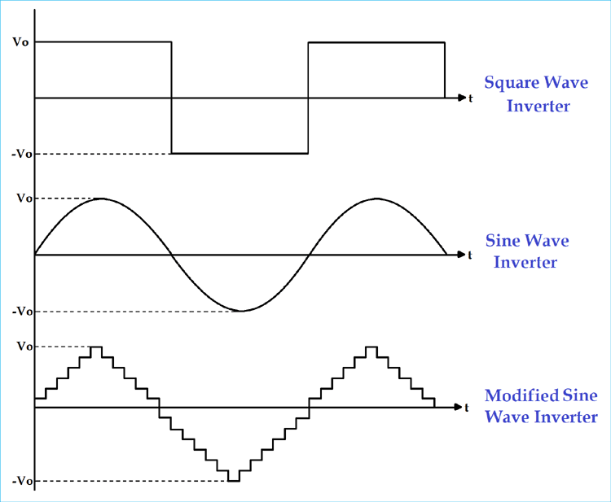

Fig 2 : Different Output Waveforms

1. On the basis of Source of the Inverter

* Voltage Source Inverter : A VSI is an inverter in which the input is a voltage source. VSI inverters are widely used as they are more efficient and have higher reliability.
* Current Source Inverters : In a CSI, the input is a current source. CSI are primarily used in applications where the requirement is of medium voltage.

1. On the basis of the type of Load

* Single Phase Inverters : Used for single phase power applications which are very common for residential and commercial purposes. Single phase inverters can either be Half-Bridge Inverters or Full Bridge Inverters
* Three Phase Inverter : These inverters also use bridge configuration and are used for applications in industries where three phase AC supply is used.

1. Scope of the Project

This project primarily focuses on the selection of the right components in the design of a half bridge and a full bridge inverter. Inverter circuits are based on switches, therefore it is important to select components which offer reliable switching properties. MOSFETs as switches are reliable and in the later sections we discuss their use as switches. Again, whether the MOSFET needs PMOS or NMOS, the type of load to be employed, etc, is discussed in the report. Half bridge and full bridge inverters are simulated by the use of SIMULINK where we employ MOSFET as switches and observe the output waveforms and conclude the discussion.

**CHAPTER 2**

**INVERTER DESIGN**

Of all the topologies innovated for inverter design, bridge topology has been one of the most popular and efficient topologies. They are primarily of two types : Half Bridge and Full Bridge which is also known as the H Bridge configuration.

The main difference between the two configurations is that the output voltage of a full bridge inverter is equal to the power supply voltage

In the course of our project, we will examine both the Half Bridge and Full Bridge configurations of inverter design.

1. Ideal Half Bridge Inverter

A half bridge inverter has two DC Voltage sources and two ideal switches. The switches primarily form the bridge part. In the circuit under consideration, we have a load connected across the bridge. This load offers some resistance and inductance. The circuit diagram is given in the figure below :

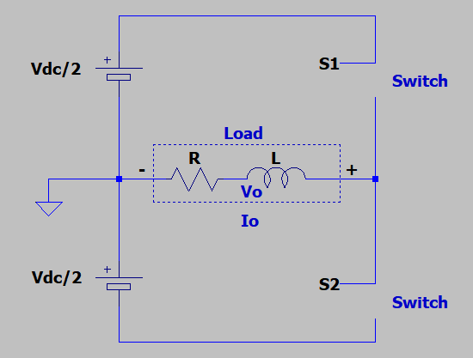

Fig 3 : Schematic diagram of the Half Bridge Configuration

In the above circuit, we have put the DC voltage source Vdc as two voltage sources Vdc/2. The circuit has been grounded between the two sources such that the load remains relative to the ground.

The primary part of a half bridge inverter circuit are the two switches in the circuit, S1 and S2. These are ideal switches. These switches can either exist in the ON state or in the OFF state. Thus, we have 4 total possible combinations in which these switches can exist.

Now, we shall discuss how these possible combinations affect the circuit.

1. Case 1 : S1 and S2 are OFF

Now if both S1 and S2 are in the OFF state and considering that the load is purely resistive, i.e. L=0, there shall be no current flowing through the load. However in our case, the load is not purely resistive and offers some inductance. Now due to the property of the inductor, it shall maintain the current in the circuit, however as both the switches are in the OFF state, there exists no path for the current to flow in the circuit. This violates the Kirchhoff's Current Law and concluding we can say that this case is not feasible for operation.

1. Case 2 : S1 is OFF and S2 is ON

Now when switch S1 is OFF and S2 is ON, the voltage across the load becomes -Vdc/2.

1. Case 3 : S1 is ON and S2 is OFF

In this case, the voltage across the load becomes +Vdc/2.

1. Case 4 : S1 is ON and S2 is OFF

Now when both the switches are in the ON state, the connection between the two voltage sources becomes short circuited and no current flows through the load. This violates the Kirchhoff's Voltage Law and we conclude that this mode of operation is not feasible.

Now, after having analyzed the four possible combinations, we can conclude that there exist only two feasible combinations for the state of the switches. This implies that the switches should be complimenting, i.e. when S1 is OFF, S2 should be ON and vice versa.

Working

Now that we have obtained the condition for the switches to be complementing, let us now examine how this actually takes place. Let us consider a specific time period, say T. Now for the first half, i.e. from 0 to T/2, the switch S1 is in the ON state and S2 is in the OFF state. During this time period, the voltage across remains +Vdc/2. During the second half, i.e. from T/2 to T, switch S1 turned to OFF state and switch S2 is in the ON state. This implies that the voltage across the load becomes, -Vdc/2. When we analyse the voltage across the load during the period T, we obtain a square wave which is an Alternating Current waveform. Thus, we have successfully converted a DC power source to a square AC wave.

1. Choice of Components
2. MOSFET as Switch

MOSFETs are excellent electrical switches as they offer higher switching rates when compared to transistors like the BJTs. In our application too, we require switches and in a practical situation there are no ideal switches, therefore we use MOSFET as switches. MOSFETs function as switches when they are biased such that they alter between the cut-off and saturation states. In the cut-off region, there is no current flowing through the MOSFET whereas during the saturation period, constant current flows through it.

In our application, we connect the gate terminal to the pulse generator which has a pulse width of 50%. Now during the period when no pulse is generated, the gate terminal of the MOSFET remains unbiased and as a result the MOSFET operates in the cutoff region and offers very high impedance, therefore, it functions as an open switch.

In case the input voltage that is applied at the gate is greater than the threshold voltage of the MOSFET, the MOSFET shall start conducting and if this voltage is greater than the pinch off voltage of the MOSFET, it should operate in the saturation region. In this state, the MOSFET offers very low resistance such that it can be assumed as a short circuit therefore acting as a closed switch.

Why MOSFET as Switch

Since inverters are devices that are needed in high-power applications, MOSFETs are the ideal choice to work as switches. It is so because MOSFETs can switch way faster than BJTs therefore increasing efficiency in applications.

1. PMOS or NMOS

In the competition between PMOS and NMOS, NMOS wins the race as they switch faster than PMOS which is basically the primary requirement and therefore they increase the efficiency.

1. Pulse generator

The pulse generator is used to provide input to the MOSFET gate in order to enable switching when required. The pulse generator in Simulink generates a square wave at regular intervals. The frequency of this wave shall be set as the desired output frequency. The pulse width is the percentage of the period for which the pulse is generated. The pulse width is set to 50% which means that for 50% of the period pulse shall be generated for the remaining it should not be generatedHowever, it shall be noted that in practical applications 50% pulse width shall not be used. The reason for this is that electrical switches take a specific amount of time to turn off. In case the pulse width is set to 50% and the circuit will be short. Therefore, pulse width must be set at around 45% to allow time for the switches to turn on/off. However for simulation purposes 50% pulse width may be used and we have used 50% pulse width in our application.

1. Load

The load may be set as per the requirements of the user. As we would see in the later sections, for a resistive load the output voltage and current are square waveforms. However, when the load is a combination of resistive and inductive, the output voltage waveform is square but the current waveform is slightly triangular with ripples which is more in resemblance with a sine wave.

1. Practical Half Bridge Inverter using MOSFETs

Simulink Model

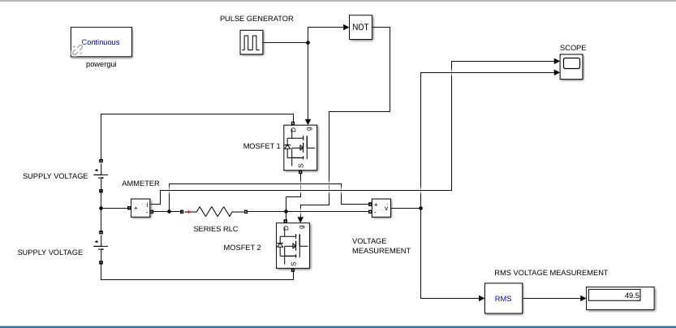

Fig 4 : Simulink Model for Half Bridge Inverter

Working

In an ideal half bridge inverter circuit, we saw the use of switches. However, in practical conditions there exist no ideal switches and thus we need to replace them by components that exhibit switching properties. In our case, we have used MOSFETs as switches, the reason for which has already been described.

In the above circuit, we have used 2 MOSFETs, two DC voltage sources of 50V each, a NOT logical operator, current and voltage measurement blocks and a pulse generator. Our aim is to generate 50Hz AC power, therefore the time period of 1 cycle shall be 20ms. In the first half cycle, MOSFET 1 is triggered and thus works as a closed switch and MOSFET 2 is not triggered which works as an open switch. At this time, the voltage across load shall be +*VDC* / 2.

During the second half cycle, MOSFET 2 is triggered and this time it works as a closed switch and the voltage across the load becomes -*V*DC / 2.

The reason for using the NOT gate is that gate pulses need to be fed to the MOSFETs which shall be generated from the pulse generator component. The pulse width is set to 50%. As we know, at a time, only one MOSFET shall be triggered. Therefore, by using the logical NOT, we let the gate pulse to one of the MOSFETs and restrict it for the other.

Simulation Results

* For Resistive Load

R = 10 Ohms

Vin = 50V + 50V DC

Vout = 49.5 V RMS AC Voltage

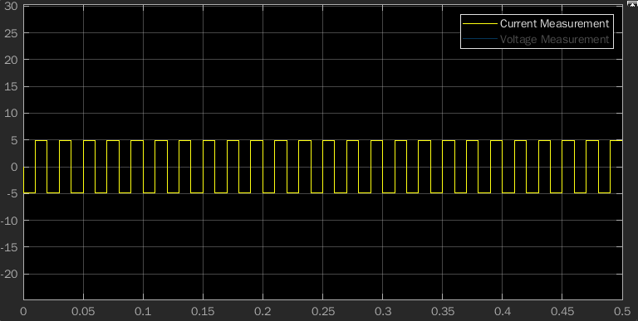

Fig 5 : Current waveform for Resistive Load (HB)

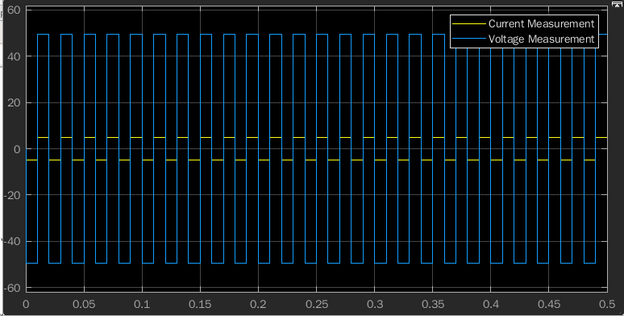

Fig 6 : Voltage waveform for Resistive Load (HB)

* For RL Load

R = 10 Ohms

L = 100 mH

Vin = 50V + 50V DC

Vout = 49.91 V RMS AC Voltage

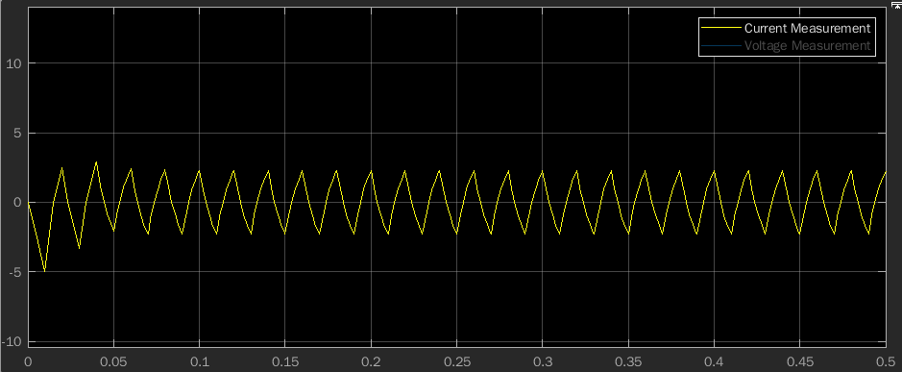

Fig 7 : Current Waveform for RL Load (HB)

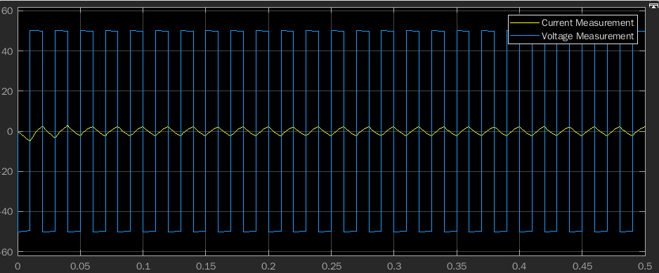

Fig 8 : Voltage waveform for RL Load (HB)

1. Ideal Full Bridge Inverter

A Full bridge inverter can take our DC source and put the full positive and negative voltage over the load. The reason a full bridge configuration is much more beneficial than a half bridge configuration is that it produces an output voltage that is equal to the input voltage, whereas in half bridge configuration, the output voltage is half of the input voltage. The figure given below shows a schematic diagram for the full bridge inverter.

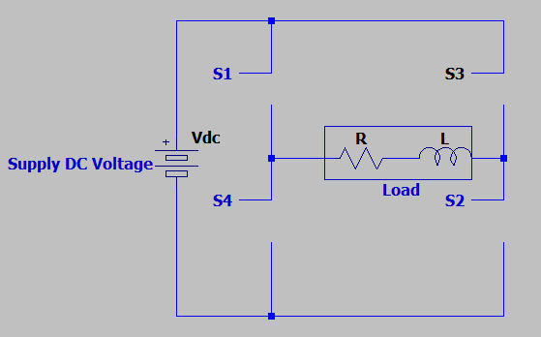

Fig 9 : Schematic diagram for full bridge inverter

In a full bridge inverter there are 4 switches : S1 S2 S3 S4, with the load connected in between the combination of these switches. This part of the circuit basically forms the *full bridge* circuit.

As we saw in the last section of half bridge inverters that the switches need to be complimenting to justify KVL and KCL laws, and as full bridge inverter is basically a combination of two half bridge circuits, here again switches S1 and S4 need to be complimentary and the same applies for switches S3 and S2.

Keeping in mind the above state of the switches, we obtain 4 feasible combinations of the states of the switches which are discussed below :-

1. Case 1 : S1 is ON and S2 is ON.

Since S1 and S2 are ON, S3 and S4 will be in the OFF state. In such a case the load appears to be connected across the load and thus the voltage across the load will be the same as that of the source i.e. equal to *VDC..*

1. Case 2 : S1 is ON and S3 is ON

Since S1 and S3 are ON, S2 and S4 will be in the OFF state. In this case, the load is shorted, therefore the potential drop across the load is 0 Volts.

1. Case 3 : S3 is ON and S4 is ON

Since S3 and S4 are on, S1 and S2 will be in the OFF state. In such a case, the voltage source appears to be connected across the load however the direction of current is different, thus the voltage across the load in this case -*V*DC.

1. Case 4 : S2 is ON and S4 is ON

Since S2 and S4 are ON, S1 and S3 will be in the OFF state. Here again, a closed loop forms around the load and the load is short circuited, therefore the potential drop across the load in such a case is 0V.

It should be noted that even when the potential drop across the load is 0V, i.e. when the load is short circuited, current still flows through the load and that is why it is a feasible condition for the operation.

So with the above analysis we understand that with a full bridge configuration we are able to obtain three different voltage values across the load. In the next section, we look at the functioning of a practical full bridge inverter with the help of a simulink model.

1. Practical Full Bridge Inverter using MOSFETs

Simulink Model

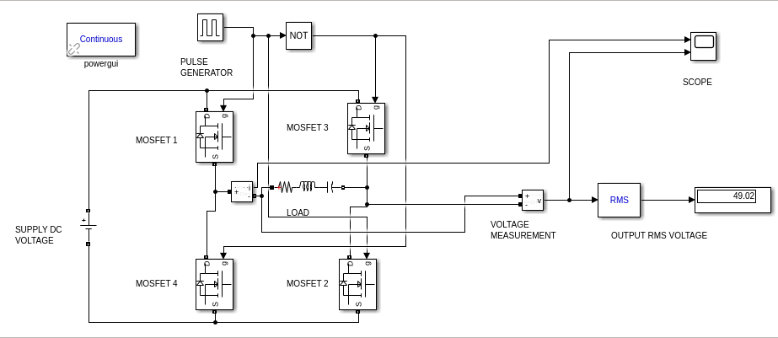

Fig 10 : Simulink Model for Full Bridge Inverter

Working

In the above circuit, we have used 4 MOSFET switches, 1 DC source of magnitude 50 Volts, RLC Load, Voltage measurement and Current measurement component, Pulse generator and the logical NOT.

The gate pulses for MOSFET 1 and 2 are the same as both of them operate at the same time. Similarly, MOSFET 3 and MOSFET 4 have the same gate pulses and operate at the same time. However, MOSFET 3 and 4 have been connected to the pulse generator after performing the logical NOT. This is done as the switches are complimenting.

In the upper half cycle, MOSFET 1 and 2 shall get triggered and current will flow through them. MOSFET 3 and 4 will act as open switches. During the lower half cycle, MOSFET 3 and 4 shall get triggered and current will flow through them, MOSFET 1 and 2 will act as open switches. The peak voltage shall be the same as the input voltage during both half cycles.

Simulation Results

* For Resistive Load

R = 10 Ohms

Vin = 50V DC

Vout = 49.02 V RMS AC Voltage

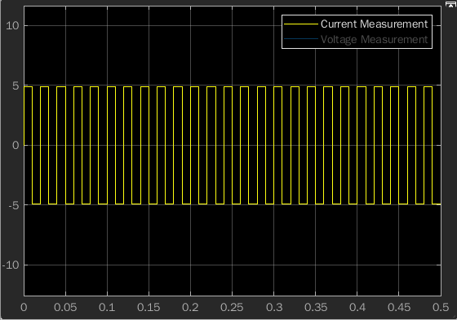

Fig 11 : Current waveform for Resistive Load (FB)

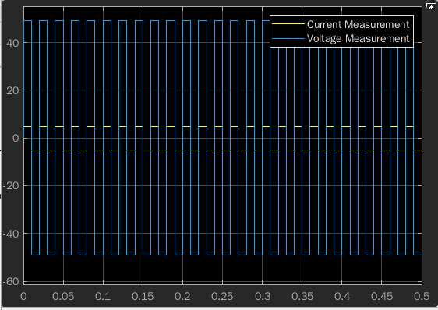

Fig 12 : Voltage waveform for Resistive Load (FB)

* For RL Load

R = 10 Ohms

L = 100 mH

Vin = 50V

Vout = 49.81 V RMS AC Voltage

P.T.O.

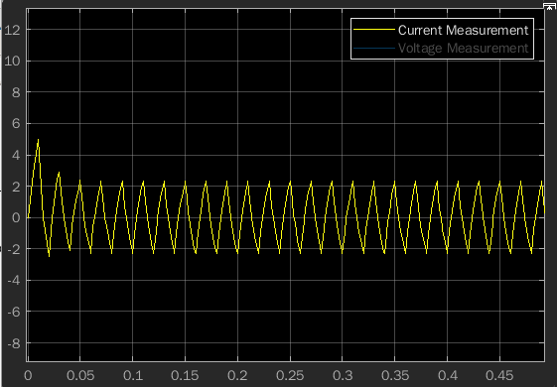

Fig 13 : Current waveform for RL Load (FB)

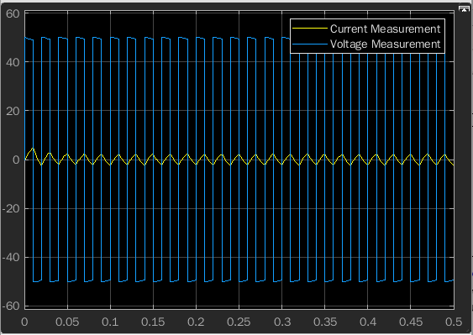

Fig 14 : Voltage waveform for RL Load (FB)

**CONCLUSION**

Inverter circuits have gained massive importance and popularity as power demands have risen over the years. There is always a requirement for reliable and efficient inverter circuits, especially in areas which do not have adequate power supply or the supply is inconsistent. People who live in remote areas have benefited with the inverter technology becoming increasingly popular and cheaper to afford.

Through our project, we identified what basically are inverter circuits and why do we actually need them. Then we get to the study of the components that are required in the design of inverter circuits and we stressed on the importance of some of the specific components which form the backbone of inverter design. Then we studied the half bridge and full bridge topologies of inverter design which are two most common implementation techniques. Putting the theory to practical application we simulated half bridge and full bridge circuits in SIMULINK and obtained output waveforms.

This is rather a more generalised study on the half bridge and full bridge inverter and in such case values of resistance, inductance were chosen with extreme accuracy. However, in a more output oriented approach, values might be adjusted in order to obtain relevant outputs. The simulation circuit shall remain the same.

A lot more study is possible on power inverters as they are increasingly popular along with new designs on the rise. With time their importance is only expected to increase and increase.

**BIBLIOGRAPHY**

1. Books :-

* Muhammad H. Rashid, “Power Electronics : Devices, Circuits and Applications”, 4th edition, United States, Pearsons, 2017.
* L. Umanand, “Power Electronics : Essentials & Applications”, India, Wiley, 2009.
* Jacob Millman and Arvin Grabel, “Microelectronics”, 2nd edition, United States, McGraw Hill International, 2017.

1. Periodicals :-

* Olusegun O. Omitola, Segun O. Olatinwo, and Taiwo R. Oyedare, “Design and construction of 1 KW (1000VA) Power Inverter”, Innovative Systems Design and Engg, Vol. 5, No.2, 2014.
* A Musa and G Galadanci, “5kVA Power Inverter Design and simulation based on converter and H-Bridge Inverter Topology”, Bayero Journal of Pure and Applied Sciences, Vol. 2, No. 1, 2009.
* D. Zhao, L. Yang, L. Wang and Q. Wang, "Research on the inverter circuit of power generation system," 2015 IEEE 5th International Conference on Electronics Information and Emergency Communication, 2015, pp. 414-417, doi: 10.1109/ICEIEC.2015.7284571.

1. Reports :-

* Atanbiyi Gabriel Babatunde, “Design, Construction and Working Principle of 2.5KVA Sine Wave, Lagos State University, OJO, December 2019.
* Shekhar Kumar Biswas and Puja Gupta, “Design, simulation and Implementation of Inverter, NIT Sikkim, May 2016.

1. Websites :-

* Electrical4U, “Power Inverters : What are they and how do they work?”, electrical4u.com, https://www.electrical4u.com/power-inverter/
* Tsuyoshi Horigome, “DC/AC Inverter (LtSpice Model)”, slideshare.net, https://www.slideshare.net/TsuyoshiHorigome/dc-ac-abmsimplified-7670457